Graphics and Animation Tools
LAB
Experiment – 6 Design of 3D ROCKET using Blender.

Step – 1:

Open a new file in blender and delete all the default objects and ADD a CYLLINDER.
Step – 2:

Now you just have to customise this cyllinder by following th steps:-
- Select the uper circle of cyllinder and using E extemd it upwards to a specific height, press enter.
- Select S to scale it a bit wide.
- Repeat unit u see three layers of seperate rectangles.
- Now you have to just extend the last layer and this time instead of expanding, you have to scale it down to a point jo that we can have the tip of rocket.
- Now coming the base of rocket, for this we have to select the other end of our base cyllinder and E(extend) it downwards and S(sclae) it wide so that we can get a skirt look for the base.
- Now go to World in setting and select new material
- Now select USE NODE and select a suitable color for your rocket

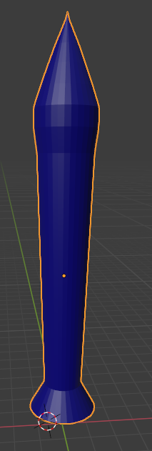
Step – 3:

After making this, we are now going to make 4 sub-rockets which help in the boost start.For that follow the listed steps.
- Add another cyllinder, and following the sme steps which we performed for the bigger rocket, build the same in smaller size.
- Now we just have to use the knife tool and create a loop cut on the upper portion of the rocket so that we can show the connection between the main and the sub rockets.
- Exteng the loop cut (which is in form of rectangle) outside and scale it down a bit.
- Reapeat extending it further and scale it up.
- Select the loop cut portion and Copy it and duplicate the same and paste it in the lower end too.
- Now select the whole combination of rocket and the joing two nodes and Copy and Duplicate it.
- Rotate each rocket so that the loop cuts / joining nodes of each rocket faces the main rocket.
- Color the set using same technique.
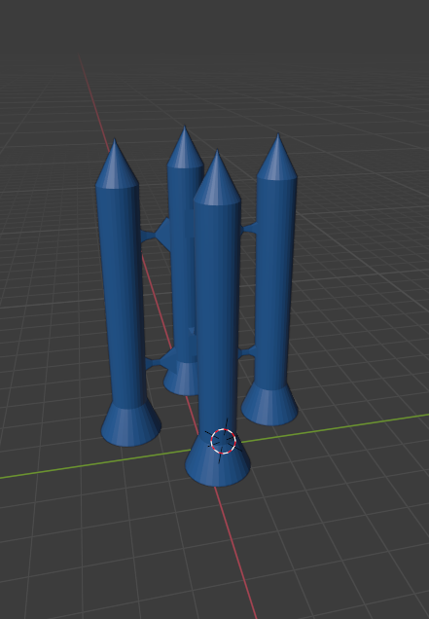

Step – 4:

Now as we are done with the main machine we have to prepare the launching pad for the same, for which we can look at the following steps:-
- To begin with Add a RECTANGLE, and add loop cuts and extending each face towards negative z axis in different depths, prepare the ground of the launching pad.
- Now on the second face make cut with knife forming a treapezium and extend it upwards, Scale it inwards wrt its width.
- Repeat twice more.
- Now extend the last layer along with the Y axis towards the rocket. And scale it down to a point.
- Copy the extended object and duplicate it thrice to form a symmentry.
- Your launching pad is ready and it might look something like:

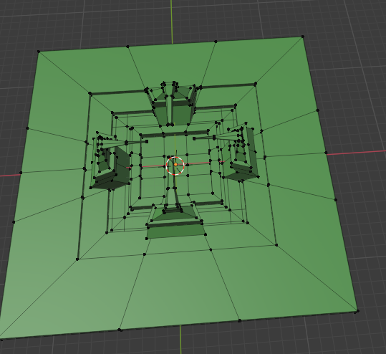

Final Output:-

